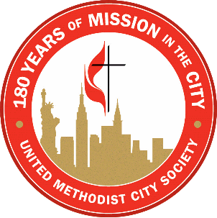
Rev. Dr. William M. James Family Memorial
SCHOLARSHIP PROGRAM

475 Riverside Drive, Suite 1922 New York, NY 10115 Tel: (212) 870-3084 Fax: (212) 870-3091

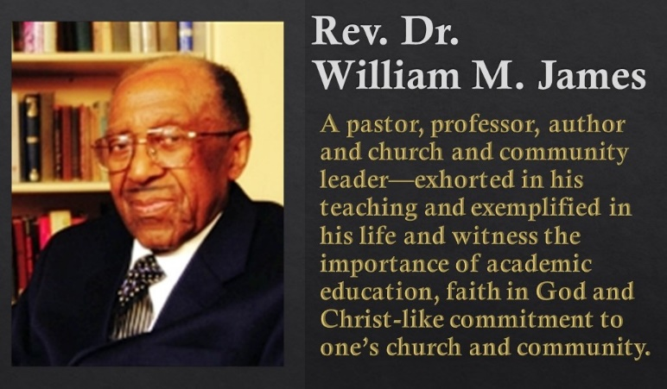
Dear Friends in Christ,
Enclosed, please find a copy of the application form for the Rev. Dr. William M. James Family Memorial Scholarship Fund established by the generosity of his friends after his passing in 2013. Dr. James had hoped that this scholarship would encourage young people who aspire to be agents for the transformation of the world.
Limited funds are available for those persons who will be attending an accredited institution of higher education, have leadership potential, and some level of financial need.
They must be recommended by their pastor, a lay person who is a leader in their local church, and a teacher or professor.
All candidates must meet the following criteria:
- Membership in a church in the New York Annual Conference;
- Enrollment in a program at an accredited college or university approved by the Scholarship Committee;
- Full time student for the academic year 2019 - 2020.
The Scholarship Committee will NOT review applications from persons who:
- Are not members of churches in the New York Annual Conference;
- Are pursuing additional advanced degrees (i.e. second master’s degree or doctoral degree);
- Are not pursuing programs that will lead to a degree or certificate;
- Do not submit the application by the deadline.
The scholarship application deadline for the 2019-2020 academic year is May 10th, 2019 at 12 Noon, if hand delivered or emailed. The application must be postmarked by May 9th, 2019 if using the U.S. Postal Service, FedEx or UPS. Complete applications can be emailed to bshillady@umcitysociety.org
Late and/or incomplete applications will not be accepted. All reference letters must come by separate cover and be mailed separately. Emails are acceptable for these references. (Your application will not be denied if we do not receive a reference letter by the deadline from your pastor, church lay leader or teacher or professor as long as we have their contact information.)
Feel free to contact me by email at bshillady@umcitysociety.org or by phone at (212) 870-3084, if you have any questions or need any further information concerning the Scholarship Fund.
In God’s love, joy and humor,
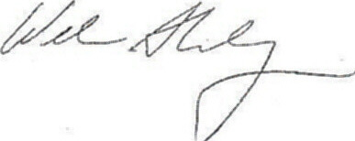
Reverend Dr. William S. Shillady
Member of the committee

UNITED METHODIST CITY SOCIETY

Guidelines for the Rev. Dr. William M. James Scholarship

For the academic year 2019-2020

Requirements and Procedures

- The applicant must be a member of a United Methodist Church in the New York Annual Conference.

- The scholarship shall be granted primarily to a person studying in a degree program at a college, university or seminary approved by the Scholarship Committee.

- Applicant must present to the Scholarship Committee a current transcript of scholastic standing in the school where the applicant has been studying, a diploma, and/or a copy of the letter of acceptance in the college or seminary where the applicant will be studying. A transcript from a previous school or previous year in a school is required; a résumé, a listing of awards and a listing of church activities is also required.

- Letters of recommendation will be required from the applicant's pastor, a lay person who is a leader in their church and a teacher or professor of the school they currently attend.

- Applications for the Rev. Dr. William M. James Scholarship are received through the office of the United Methodist City Society, 475 Riverside Drive, Room 1922, New York, NY 10115. Attn: Rev. Dr. William S. Shillady. Email of the application will be accepted at bshillady@umcitysociety.org

- The scholarship granted shall be paid to the educational institution involved. For the check to be issued to the business office of the school, it shall be the responsibility of the recipient to send the following to the Scholarship Committee at the United Methodist City Society office:

- The applicant’s proof that he/she is fully registered in the college or seminary.
(Official registration form)

- The applicant’s course list.

- The business office bill for tuition.
- Grants will vary depending upon full time and part time programs.

- If a student leaves the school after being granted a scholarship, the school shall return any remaining balance to the Rev. Dr. William M. James Scholarship Fund.

- Financial need will be taken into consideration. Please complete the financial information portion of the application and provide a copy of your Federal 1040 form, and/or or your parents' 1040 form (The first two summary pages.) Additional forms and information may be requested. Also provide a copy of the Application for Federal Student Aid (FAFSA) form if applicable.

- Scholarship monies will be used in the following priority areas:
  - Undergraduate degree program
  - Graduate first-degree program

- The funds will NOT be available for those who already hold a master’s degree or doctoral degree and those who are doing additional graduate work or continuing education.

- Scholarships are awarded on an annual basis. Applicants must apply separately each year.

The deadline for scholarship application is May 10th, 2019 at 12 Noon if hand delivered or sent by email. The application must be at the United Methodist City Society offices via USPS, UPS, or FED EX (Postmarked – May 9th, 2019). Complete applications can be emailed to bshillady@umcitysociety.org.

All questions should be addressed to:
The Rev. Dr. William M. James Scholarship Committee
c/o Rev. Dr. William S. Shillady
Phone: 212-870-3094
Fax: 212-870-3091
Email: bshillady@umcitysociety.org

REV. DR. WILLIAM M. JAMES FAMILY

SCHOLARSHIP APPLICATION

The Rev. Dr. William M. James Family Fund Scholarship was established in 2013 following Rev. James' death to encourage young people who aspire to become agents for the transformation of the world. The applicant must attend an accredited institution of higher education, have leadership potential, financial need and be recommended by a local pastor of a United Methodist Church.

name:

address:

telephone: email:

Date of birth: Place of birth:

how long have you been a member of the united Methodist church?

church name:

PASTOR:

how long have you been a member of this church?

if less than 2 years, please list your other churches and the number of years you were
a member:

district:
district superintendent:
CURRENT SCHOOL:

Which Institution will you attend in the fall of 2019?

what is your current level of study at this school?

FULL TIME ☐ PART TIME ☐ HOW MANY COURSES WILL YOU TAKE?

CREDITS TO BE EARNED:
AWARD PROCESS

THE APPLICANTS MUST BE BETWEEN THE AGES OF 16-25, MAINTAINED AT LEAST A C AVERAGE IN HIGH SCHOOL AND A 2.75 GPA OR BETTER WHILE IN COLLEGE OR SEMINARY TO RECEIVE A SCHOLARSHIP.

FUNDS WILL NOT BE AVAILABLE TO THE STUDENT UNTIL CLASSES HAVE STARTED AND THE SCHOLARSHIP COMMITTEE HAS RECEIVED THE VERIFICATION OF ENROLLMENT FROM THE SCHOOL’S REGISTRAR. THE CHECK WILL BE MADE PAYABLE TO THE SCHOOL.

THE AMOUNT OF THE AWARD IS DETERMINED BY FUNDS AVAILABLE AND THE DECISION OF THE REVIEW COMMITTEE BASED ON ITS REVIEW OF THE APPLICATION AND ALL THE REQUIRED DOCUMENTS.

PLEASE ATTACH THE FOLLOWING:

- Letters of Recommendation from:
- Pastor
- Local Church Leader
- Teacher or Professor

These letters of recommendation are to be sent directly to Rev. Dr. William S. Shillady at The United Methodist City Society; e-mail: bshillady@umcitysociety.org. Please encourage your recommenders to meet the
May 10th, 2019 deadline.

Please list the names of your recommenders’, their e-mail address or if no e-mail address, their mailing address.

PASTOR’S NAME:
email ADDRESS:
MAILING ADDRESS:

LOCAL CHURCH LEADER:
email ADDRESS:
MAILING ADDRESS:

TEACHER OR PROFESSOR:
email ADDRESS:
MAILING ADDRESS:

(please note that your application must be submitted by the deadline.)

you must request your pastor, Local Church Leader and Teacher or Professor to send a letter of reference separately and independently. your application will not be denied if we have not received the reference letter by the deadline.

- Certified Official Copy of your Academic Transcript from your current school.

- Essay - Please write an essay of your aspirations to become a leader for the transformation of this world. (Write this essay on a separate paper and attach to your application)

- Complete the Financial Statement and send the required 1040 forms.

- Résumé – List any awards received and include your church activities.

FINANCIAL STATEMENT

- have you ever received a scholarship from this fund? Yes ☐ No ☐

- do you currently have any outstanding loans/debts? Yes ☐ No ☐
(If the answer is yes, please list loans/debts on a separate sheet of paper and submit with this application)

- what are your estimated expenses for the current school year?

Tuition and fees: ……………………... | $
How many credits does this represent?
Books: ……………………………… | $
Housing: ……………………………… | $
Food: …………………………………. | $
Other Living Expenses: ……………… | $
Other Expenses: ……………………… | $
Total: …………………………………. | $

- what are your sources of income for the current school year?

Salary: ………………………………... | $
Scholarships / Grants: ………………... | $
Savings: ………………………………. | $
Loans: ………………………………… | $
Gifts: …………………………………. | $
Total: ………………………………... | $

PLEASE PROVIDE A COPY OF THE TWO PAGES OF YOUR FEDERAL 1040 FORM FROM 2018
AS VERIFICATION OF THE ABOVE INCOME. SEND A COPY OF FAFSA, IF APPLICABLE.

V. please answer the following questions about your employment (IF EMPLOYED):

Employer:

Nature of Business:

Position: Salary:

Other Income: ☐ YES ☐NO If yes:

VI. please answer the following questions about your household composition:

- are you married? ☐ YES ☐ NO

- is your spouse employed? ☐ YES ☐NO IF YES, WHAT IS THEIR SALARY?

- how many children reside in your household?

VII. please use the space below to provide any additional information that YOU FEEL will help the committee in understanding your current financial situation.

VIII. if you are below Age 21, PLEASE PROVIDE the information requested below for your parents or other guardians (PLEASE PROVIDE A COPY OF THE TWO PAGES OF YOUR PARENTS FEDERAL 1040 FORM FROM 2018 AS VERIFICATION OF THE INCOME)

MOTHER OR GUARDIAN 1
NAME:
ADDRESS:
EMPLOYER:
TYPE OF BUSINESS:
POSITION: |  | SALARY: $
TOTAL NO. OF DEPENDENTS: |  | TOTAL NO. OF CHILDREN IN COLLEGE:

FATHER OR GUARDIAN 2
NAME:
ADDRESS:
EMPLOYER:
TYPE OF BUSINESS:
POSITION: |  | SALARY: $
TOTAL NO. OF DEPENDENTS: |  | TOTAL NO. OF CHILDREN IN COLLEGE:

If any requested information is missing,
this application will NOT be considered by the Scholarship Review Committee.

signature of Applicant:

date:

THIS APPLICATION MUST BE IN THE OFFICES OF THE UNITED METHODIST CITY SOCIETY
BY NOON ON FRIDAY, MAY 10TH, 2019.

If using UPS, USPS or FEDEX, it must be postmarked by May 9th, 2019 and mailed to:
REV. DR. WILLIAM S. SHILLADY
475 RIVERSIDE DRIVE, SUITE 1922
NEW YORK, NY 10115

You may fax or email the COMPLETED APPLICATION to:
Fax: 212-870-3091
Email: bshillady@umcitysociety.org

